# **TensorFlow implementation**

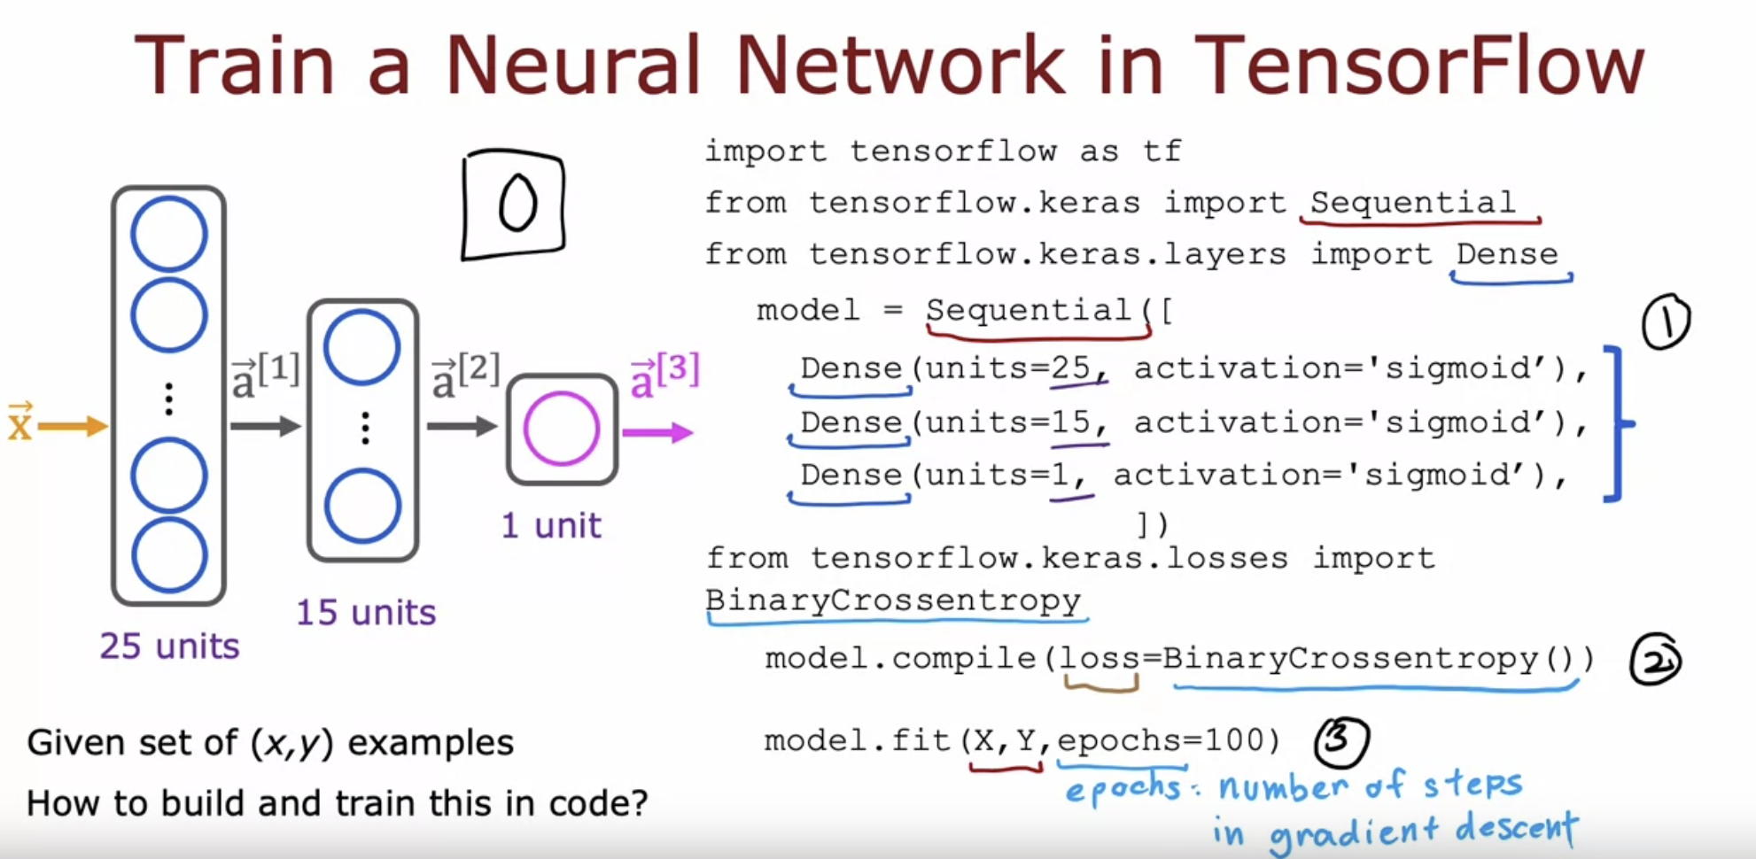

Average Loss over entire training example

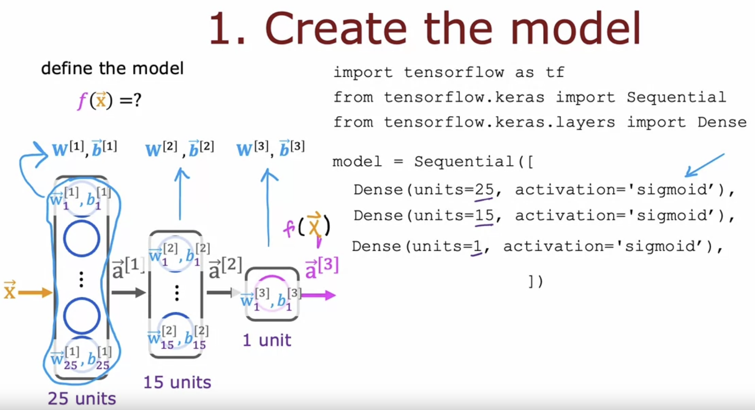

Optimizing this cost function will result in fitting the neural network to your binary classification data.

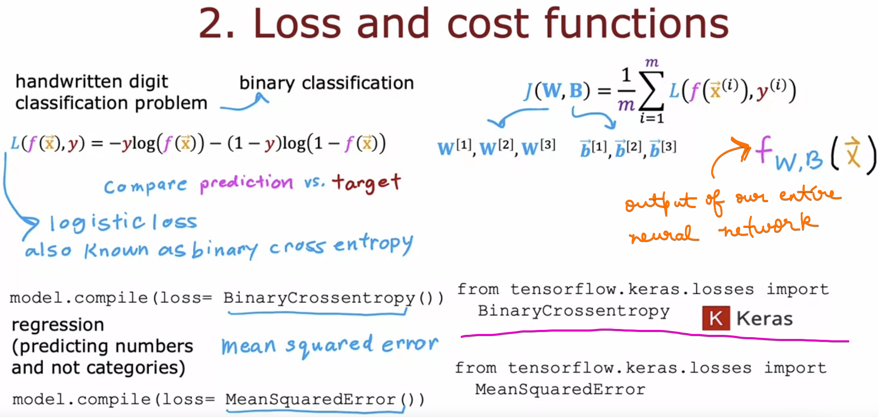

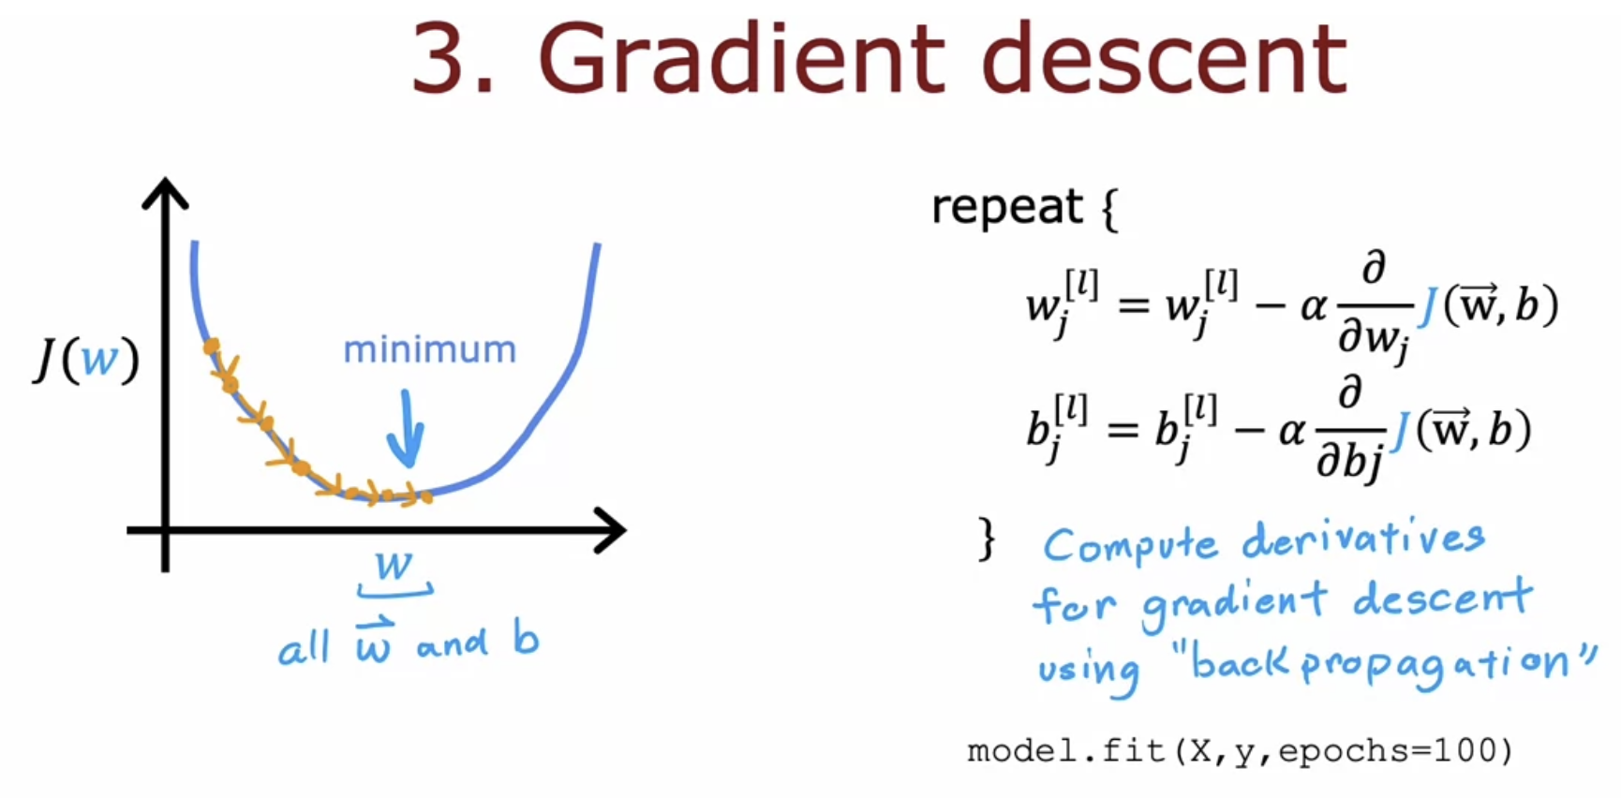

# **Quiz**

